Insert company logo here

COVID-19
Risk Management Plan
Client Template

Version # | Date
1 | XX/XX/2020

***Disclaimer***
This template has been provided to assist SRG Group clients in establishing their own Risk Management Plan for their companies/organisation’s requirements. Please ensure all areas highlighted yellow are changed to reflect the company name and that the document is reviewed and altered to appropriately suit the needs and specific requirements of your organisation. SRG Group takes no responsibility for any information not included in this document prior to your submittal.

Table of Contents

1.0 Introduction and Scope 3
1.1 Introduction 3
1.2 Scope 3
2.0 Responsibilities 3
3.0 COVID-19 Policy 4
4.0 Action Plan 6
5.0 Infection Control Plan 10
6.0 Risk Controls 16
6.1 Engineering Controls 16
6.2 Administrative Controls 16
6.3 Safe Work Practices 17
6.4 Personal Protective Equipment (PPE) 17
7.0 Appendix A - Forms 19
Form 7.1 Record of Training Attendance 19
Form 7.2 Poster – Know the signs 20
Form 7.3 Poster – Stop the spread 21
Form 7.4 22
Pre-work COVID-19 Questionnaire (Client) 22
Form 7.5 24
Pre-work COVID-19 Questionnaire (Subcontractor/ Supplier) 24
Form 7.6 Risk Assessment for COVID-19 26

- Introduction and Scope
  - Introduction
As an employer/contractor/company, I/we have a legal responsibility to protect the health, safety and welfare of our employees and contractors.
This risk management plan will:
- outline our method to ensure the safety of our employees and clients.
- help ensure that the risks to all persons with possible exposure to Coronavirus (COVID-19) are minimised.
  - Scope
The purpose of this plan is to outline how Company Name will decrease the spread of COVID-19 and lower the impact in our workplace.
This includes activities in the following areas:
- maintaining a safe and healthy work environment.
- reducing transmission amongst employees, and
- maintaining business operations.

- Responsibilities
Directors/Management
- Ensure a Safe and Healthy Workplace for employees, visitors and clients.
- Have procedures in place to help prevent and control the spread of the virus.
- Ensure full compliance with all relevant Government policies and guidance.
- Keep up to date with the latest COVID-19 information and advice to ensure that any action taken is measured and appropriate.
- Provide information, advice and training to employees in relation to the virus, isolation/quarantine and when staff should not attend work.
- Develop a contingency plan to manage staff absences.
- If an employee is confirmed to have COVID-19, immediate contact is to be made with the recommended COVID-19 local authority as directed by the Australian Government Department of Health. The company is to follow the recommendations provided and inform employees and co-workers about possible exposure to COVID-19 but maintain confidentiality. Advise employees to seek immediate medical advice if they develop symptoms or are concerned about their health.
- Ensure all confirmed cases of COVID-19 that are work related are notified in accordance with Government requirements.

Employees
- Take reasonable and responsible care of their own health and safety and not adversely affect the health and safety of others.
- Follow company procedures and advice in relation to COVID-19.
- Complete any training and information sessions provided by Company Name.
- Wash hands often, with soap and water, or carry hand sanitiser and use as recommended.
- Cover nose and mouth with elbow or use a disposable tissue when coughing or sneezing, dispose of tissues immediately after use and wash hands or apply hand sanitiser.
- Avoid close contact with anyone who has cold or flu-like symptoms.
- See a health care professional if feeling unwell.
- If unwell, avoid contact with others (including shaking hands or other touching, such as hugging).
- If exhibiting symptoms contact Manager or HR Advisor of company to advise of potential COVID-19 case.

- COVID-19 Policy
Commitment
Company Name is committed to ensuring the health and wellbeing of our employees, stakeholders and clients. We will take all reasonable steps to prevent and manage the spread of COVID-19 through the implementation of procedures that are consistent with guidelines of Health Authorities.

Scope
This policy covers all activities undertaken by Company Name employees, subcontractors, clients and other stakeholders both on our own premises, client sites and third-party sites.

Objective
This policy aims to eliminate the spread of COVID-19, both within our organisation and our community at large by maintaining a clean, safe and healthy environment for employees, their families, our clients and members of the community.

Policy
Company Name is committed ensuring the health and wellbeing of our employees, stakeholders and clients.

Company Name will:
- Monitor Government and Health Department updates on Coronavirus (COVID-19);
- Identify the potential hazards for their employees and business in relation to potential COVID-19 exposure;
- Undertake a suitable and sufficient risk assessment to mitigate or manage potential exposure of COVID-19 to their employees and business, achieving as low as reasonably practicable (ALARP) outcomes.;
  - Employees are to be consulted (or their representatives) in the risk assessment process, acknowledging they will have additional information about how work completed and how risks & hazards can be effectively mitigated in the workplace;

- Review outcomes and actions from the risk assessment to ensure they have been effectively implemented.
- Review the risk assessment when there is a reason to suspect it is no longer valid or there has been a significant change in the matters to which it relates;
- Follow good practice and retain the risk assessment(s) while they remain relevant and in adherence to the organisations retention policy;
- Review and revise this policy at least annually.

_______________________________________________
Signed by Director

________________________________________________
Dated

- Action Plan
Reduce transmission among employees
Company Name will actively encourage sick employees to stay home:
- Employees who have symptoms (i.e., fever, cough, or shortness of breath) should notify their supervisor and stay home.
- Working from home provisions have been made available to employees to ensure their work can be completed at home and in accordance with recommendations from the Government to isolate if possible ***Delete if employees not working from home***
- Sick employees should follow the Health Department-recommended steps. Employees are not permitted to return to work until the criteria to discontinue home isolation are met, in consultation with healthcare providers and state and national health departments.
- Employees who are well but who have a sick family member at home with COVID-19 should notify their supervisor and follow recommended precautions and not come to work.

Identify how employees might be exposed to COVID-19 at work:
Some employees may be at higher risk for serious illness, such as older adults and those with chronic medical conditions.
Company Name will (where possible) minimise face-to-face contact between these employees and/or assign work tasks that allow them to maintain a two-meter exclusion zone from other employees, customers and visitors, or to work from home if possible.
A documented Risk Assessment will be undertaken to identify where and how employees might be exposed at work and ensure there are adequate controls.
Separate sick employees:
Employees who appear to have symptoms (i.e. fever, cough, or shortness of breath) upon arrival at work will be instantly sent home:
- The employee should contact the National Coronavirus Helpline (1800 020 080) and will be instructed on next actions to take .
- All other employees will be notified of a potential exposure and further information will be provided in accordance with government recommendations.
If an employee is confirmed to have COVID-19 infection, we will inform fellow employees of their possible exposure to COVID-19 in the workplace but maintain confidentiality. The fellow employees should then self-monitor for symptoms (i.e., fever, cough, or shortness of breath) and follow the direction of the Department of Health.
Educate employees about how they can reduce the spread of COVID-19:
Employees can take steps to protect themselves at work and at home. Older people and people with serious chronic medical conditions are at higher risk for complications.
- Follow Company Name policies and procedures related to illness, cleaning and disinfecting, and work meetings and travel.
- Stay home if you are sick, except to get medical care. Learn what to do if you are sick.
- Inform your supervisor and do not attend work if you have a sick family member at home with COVID-19.
- Wash your hands often with soap and water for at least 20 seconds. Use hand sanitizer with at least 60% alcohol if soap and water are not available.
- Avoid touching your eyes, nose, and mouth with unwashed hands.
- Cover your mouth and nose with a tissue when you cough or sneeze or use the inside of your elbow. Throw used tissues in the trash and immediately wash hands with soap and water for at least 20 seconds. If soap and water are not available, use hand sanitizer containing at least 60% alcohol.
- Clean AND disinfect frequently touched objects and surfaces.
- Dirty surfaces can be cleaned with soap and water prior to disinfection.
- Avoid using other employees’ phones, desks, offices, or other work tools and equipment, when possible. If necessary, clean and disinfect them before and after use.
- Practice social distancing by avoiding large gatherings and maintaining distance (approximately 2 meters) from others when possible.

Maintain healthy business operations
Company Name will identify a workplace coordinator who will be responsible for COVID-19 issues and their impact at the workplace.
Implement flexible sick leave and supportive policies and practices.
- Company Name will ensure that sick leave policies are flexible and consistent with guidance from FairWork Australia and that employees are aware of and understand these policies.
- Company Name does not require a positive COVID-19 test result or a healthcare provider’s note for employees who are sick and wish to self-quarantine to validate their illness, qualify for sick leave. All leave will be paid in accordance with the FairWork Australia Requirements and guidelines. However, the employer reserve the right to ensure the health & wellbeing of its other employees and clients and request employee does not come back to work if posing a potential health risk.

Assess essential functions
- Company Name is prepared to change our business practices if needed to maintain critical operations (e.g., we will identify alternative suppliers, prioritise existing customers, or temporarily suspend some of our operations if needed).
- Company Name will identify where possible alternate supply chains for critical goods and services.
- Company Name will talk with companies that provide our business with contract or temporary workers about the importance of sick employees staying home.
- We will determine how to operate if absenteeism spikes from increases in sick employees, those who stay home to care for sick family members, and those who must stay home to watch their children.

Company Name has implemented social distancing (avoiding large gatherings and maintaining distance of approximately 2 meters) from others when possible (e.g., breakrooms and cafeterias).
Strategies that Company Name uses include:
- Implementing flexible worksites (working from home)
- Implementing flexible work hours (e.g., staggered shifts)
- Increasing physical space between employees at the worksite
- Increasing physical space between employees and customers (e.g., drive through, partitions)
- Implementing flexible travel options (employees are not to share cars travelling to site)
- Delivering services remotely (e.g. phone, video, or web)
- Delivering products through curbside pick-up or delivery
***remove dot points not relevant to company***

Maintain a healthy work environment
Company Name has implemented and encourages proper hygiene for employees, customers, and worksite visitors:
- Provide tissues and no-touch disposal receptacles.
- Provide soap and water in the workplace. If soap and water are not readily available, use alcohol-based hand sanitizer that is at least 60% alcohol. If hands are visibly dirty, soap and water should be chosen over hand sanitizer. Ensure that adequate supplies are maintained.
- Place hand sanitizers in multiple locations to encourage hand hygiene.
- Place posters that encourage hand hygiene to help stop the spread at the entrance to your workplace and in other workplace areas where they are likely to be seen.
- Employees and visitors/clients must use noncontact methods of greeting.

Company Name will perform routine environmental cleaning:
- Routinely clean all frequently touched surfaces in the workplace, such as workstations, keyboards, telephones, handrails, and doorknobs.
- If surfaces are dirty, they should be cleaned using a detergent or soap and water prior to disinfection.
- Employees are not to use other employees’ phones, desks, offices, or other work tools and equipment, when possible. If necessary, clean and disinfect them before and after use.
- Cleaning products and materials will be provided so that commonly used surfaces (for example, doorknobs, keyboards, remote controls, desks, other work tools and equipment) can be wiped down by employees before each use.
- For disinfection, most common household disinfectants should be effective.
- Safety Data Sheet (SDS) must be held for all cleaning chemicals.

Handling of Cash
For intermittent handling of cash, staff members will be advised to perform hand hygiene immediately after handling cash (either soap and water or hand sanitiser, whichever is available). This means hand sanitiser needs to be available to support this across a range of settings that don’t currently have this.
For longer periods of cash handling, staff members should wear gloves while handling cash, and then carefully remove the gloves and perform hand hygiene at the end of the period of cash handling. *** delete if not relevant to business***
Notification of COVID-19 incidents
All confirmed COVID-19 cases that are work related – that is, arising from the business or undertaking of the employer will be notified to the regulator in accordance with Government and Comcare recommendations.
Comcare will be notified of a notifiable incident under the Commonwealth Work Health and Safety Act 2011 by:
- telephone 1300 366 979, or
- complete and submit the on-line incident notification form, or
- download and complete the incident notification form and email it to notify@comcare.gov.au.

Company Name will include as much information as possible about the notifiable incident. Key information will include, but not limited to:
- Sequence of events leading up to incident.
- What activity was being performed at the time of incident.
- Remedial action taken to ensure the immediate health and safety of employees and other persons.
- Is the activity that resulted in this incident undertaken at any other workplace or location? If so, what has been done to prevent a similar incident at those workplaces.

Monitoring the implementation of controls
Company Name will in consultation with employees, regularly review the effectiveness of controls in place and update if necessary.
Company Name will consider employees who may need to be reassigned to priority tasks that are unfamiliar to them. These employees may be particularly susceptible to injury while adjusting to the new work (e.g.: fatigue; anxiety; sprain/strains; occupational overuse injury; etc). Control measures for these risks could include:
- close supervision and support, monitoring workloads and job demands
- specific job task training
- adapting work arrangements (e.g.: work from home; staggered work shifts, etc)
- clear (adapted) performance expectations.

Recovery
Company Name will plan a recovery process to ensure work activities return to normal in a managed way:
- to progressively suspend local risk control measures as the pandemic subsides, to be on a schedule that is compatible with advice from the Health Department,
- to consider the need for training for employees re-tasked to priority areas while business activities are transitioning back to normal,
- ensure employees are consulted about skills, training needs and workloads before they are moved to new work,
- to ensure effective communication and consultation with employees both in the workplace and those at home waiting to recommence normal work arrangements,
- to ensure access to work-based support as it is likely some employees will suffer psychological consequences. Employees who are affected by the death of colleagues, friends or family will need extra support.

Monitoring and Improvement
Company Name will keep informed with up-to-date disease advice, information and any directives issued by the Health Department – it will assist with good WHS planning as the virus spreads.
Company Name, in consultation with employees and/or their HSRs, will review and update controls in place in line with updated and new information.
- Infection Control Plan
Purpose
This procedure has been developed to protect employees, volunteers and contractors that may be at risk from infection as part of their work.
Definitions
Hand hygiene: A general term applying to processes aiming to reduce the number of microorganisms on hands. This includes application of a waterless antimicrobial agent (e.g. alcohol-based hand rub) to the surface of the hands; and use of soap/solution (plain or antimicrobial) and water (if hands are visibly soiled), followed by patting dry with single-use towels.
Close Contact: Defined as people who have been:
- Face-to-face contact with a person infected with the virus for at least 15 minutes; or,
- In the same enclosed space for at least 2 hours with an infected person

Responsibility
Directors/Managers/Supervisors
- prevent occupational exposure to infection hazards;
- prevent occupational risks from chemicals or processes used for recommended infection prevention and control activities

Employees
- Must take care to ensure their own safety and to not adversely affect the health and safety of other persons
- always follow specific established infection prevention and control policies and reasonable instructions
- use only equipment that is in good condition.

Procedure
Standard Precautions
Company Name will ensure that the following standard precautions are always applied:
- hand hygiene;
- the use of personal protective equipment;
- the safe use and disposal of sharps;
- routine environmental cleaning;
- reprocessing of reusable medical equipment and instruments
- waste management.

Standard precautions should be used in the handling of blood (including dried blood) and all other body substances, secretions and excretions.
Routine hand hygiene
Hand hygiene must be performed using the correct procedure (below) in the following situations as a minimum:
- contact with any person
- cleaning equipment
- visiting a client premises
- handling equipment or instruments that have been in contact with another person
- handling laundry, equipment waste
- any other contact or exposure to objects or client property, door handles etc.

Hand hygiene must also be performed after the removal of gloves. All personnel should perform hand hygiene between clients. Company name will ensure employees have access to a liquid soap dispenser, and paper towels. Alcohol-based hand rubs will also be provided for use in conjunction with handwashing.

In addition to the above, hand hygiene will be performed in other situations, before and after:
- Starting/leaving work
- Eating/handling of food/drinks
- Using computer keyboard
- Hands becoming visibly soiled
- Visiting the toilet
- Being in client areas or areas accessible to the public
- Removing gloves
- Handling laundry/equipment/waste
- Blowing/wiping/touching nose and mouth

Additional requirements:
- Dry hands with a disposable towel after washing.

Correct handwashing procedure:
- Wet hands with running water
- Place soap on palms
- Rub hands together to make a lather
- Scrub hands vigorously for 20 seconds
- Dry hands with a disposable towel
- Turn off tap using the disposable towel

Please see the below example from Health Direct on the recommended hand washing procedure:
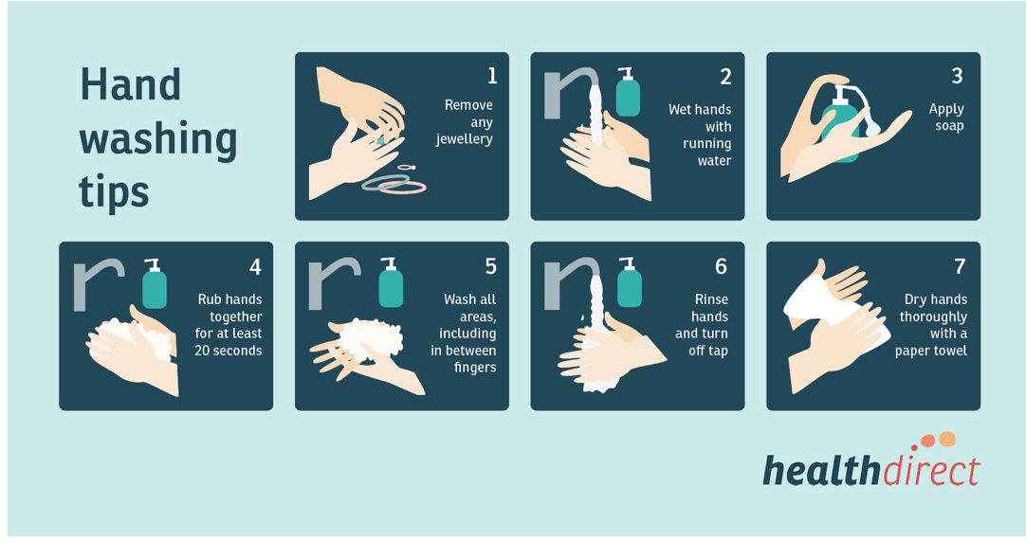

Correct use of alcohol-based hand rubs:
- Place alcohol-based hand rub on palms
- Apply to all surfaces of hands
- Rub hands together until dry

Environmental infection control
Isolation area
Company Name will immediately isolate people who have signs and/or symptoms of COVID-19. We will undertake the following measures:
- Move potentially infectious people to a location away from employees, customers, and other visitors.
- If there is no specific isolation room, designated areas with closable doors may serve as isolation rooms until potentially sick people can be removed from the worksite.
- Limit spread of the respiratory secretions of a person who may have COVID-19. Provide a face mask, if feasible and available, and ask the person to wear it, if tolerated.
Note: A face mask (also called a surgical mask, procedure mask, or other similar terms) on a patient or other sick person should not be confused with PPE for an employee; the mask acts to contain potentially infectious respiratory secretions at the source (i.e., the person’s nose and mouth).
- Arrangements will be made for their transport either to a doctor or to their home, public transport should not be used.
- A record will be kept of those who become ill and leave the workplace and the people they have had close or casual contact with.
- When a person with suspected infection has left the workplace, we will ensure that their workstation, work area and communal areas they have been in are thoroughly cleaned and disinfected.

Cleaning and disinfection of equipment and environmental surfaces
- Wear gloves when cleaning and disinfecting.
- Wash hands afterwards.
- First, clean surfaces and equipment and then use an approved cleaner known to kill Coronavirus, applied according to manufacturer’s instructions.
- Clean and disinfect all equipment, door handles, surfaces, computers, shared areas and client areas.

Cleaning when sick employee is suspected or confirmed to have COVID-19
Perform enhanced cleaning and disinfection after persons suspected/confirmed to have COVID-19 have been in the area as follows:
Recommended cleaning process
Gather the required items needed for cleaning before entering the area and cleaning begins. This may include the following:
- Task specific personal protective equipment (PPE)
- cleaning equipment and solutions
- rubbish waste bag
- alcohol-based hand rub.

Personal protective equipment recommendations
People entering the room and the person with suspected or confirmed COVID-19 should wear a surgical mask if the person with COVID-19 remains in the room while the cleaning is done.

People should use the following process to safely put on the recommended personal protective equipment before entering the area:
- Clean your hands. This can be done with either liquid soap and running water or alcohol- based hand rub.
- Put on a disposable apron. Fasten the back of the apron at the neck and waist.
- If the person with suspected or confirmed COVID-19 is in the area to be cleaned put on a surgical mask. Secure the ties of the mask at the middle of the head and neck. Fit the flexible band to nose bridge and ensure mask is fitted snug to face and below the chin. Do not touch or adjust the mask until you are ready to remove the mask.
- Put on protective eyewear to protect your eyes from the cleaning fluids.
- Put on disposable latex or vinyl gloves.
- The purpose of personal protective equipment is to reduce the risk of direct contact with contaminated surfaces.

Once cleaning is completed, place all disposable cleaning items in the rubbish waste bag. Waste does not need any additional handling or treatment measures. Reusable cleaning items, such as mop heads, should be cleaned as per the cleaning recommendations below.
People should use the following process to safely remove personal protective equipment:
- Remove and dispose of gloves. The outside of gloves is contaminated. Remove gloves being careful not to contaminate bare hands during glove removal.
- Clean your hands. This can be done with either liquid soap and running water or alcohol-based hand rub.
- Remove and dispose of apron. The apron front maybe contaminated. Untie or break fasteners and pull apron away from body, touching the inside of the apron only.
- Clean your hands. This can be done with either liquid soap and running water or alcohol-based hand rub.
- Remove protective eyewear/face shield. The outside of protective eyewear/face shields maybe contaminated. Remove eyewear/face shield by tilting the head forward and lifting the head band or ear pieces. Avoid touching the front surface of the eyewear/face shield. Reusable protective eyewear should be placed into a container and washed in detergent and water and allowed to completely air dry.
- Clean your hands. This can be done with either liquid soap and running water or alcohol-based hand rub.
- Remove and dispose of surgical mask if worn. Do not touch the front of the surgical mask. Remove the surgical mask by holding the elastic straps or ties and remove without touching the front.
- Clean your hands. This can be done with either liquid soap and running water or alcohol-based hand rub.

Personal protective equipment can be disposed into general waste in accordance with proper waste management practises.
Once you enter the area, avoid touching your face and don’t touch or adjust your face mask if one is worn.
If wearing a mask, it should be either on or off – ensure it always covers both the nose and mouth and don’t let it dangle from the neck.
Cleaning recommendations
- Once the person with suspected or confirmed COVID-19 vacates a room, cleaning can commence immediately. The room and all hard surfaces in the room should be physically cleaned. All furniture, equipment, horizontal surfaces and all frequently touched surfaces (e.g. door handles) should be thoroughly cleaned.

Cleaning of hard surfaces (e.g. bench tops) should be done using either:
- a physical clean using detergent and water followed by a household bleach or hospital-grade bleach solutions that are readily available from retail stores. Follow manufacturer’s directions for use.
- Bleach solutions should be made fresh daily and gloves should be worn when handling and preparing bleach solutions. Protective eyewear should be worn in case of splashing – refer to manufactures SDS for specific instructions.

Cleaning equipment including mop heads and cloths should be laundered using hot water and completely dried before re-use. Cleaning equipment, such as buckets, should be emptied and cleaned with a new batch of chlorine bleach solution and allowed to dry completely before re-use.
Staff training and education
Infection control training and education will be documented in the employee training record.

- Risk Controls
  - Engineering Controls
Engineering controls involve isolating employees from work related hazards. In workplaces where they are appropriate, and where practicable, to reduce or minimise exposure to COVID-19, Company Name will implement the following:
- Increasing ventilation rates in the work environment.
- Installing physical barriers, such as clear plastic sneeze guards.
- Installing a drive-through window for customer service.
- Re-design office, floor or meeting room layouts to meet social distancing requirements
- Providing isolation rooms or designated isolation areas for ill employees until they can leave the workplace.

  - Administrative Controls
To reduce or minimise exposure to COVID-19, Company Name will implement the following Administrative controls:
- Requiring sick employees to stay at home.
- Minimising contact among employees, clients, and customers by replacing face-to-face meetings with virtual communications and implementing telework if feasible.
- Providing employees with up-to-date education and training on COVID-19 risk factors and protective behaviours (e.g., cough etiquette and care of PPE).
- Training employees who need to use protecting clothing and equipment how to put it on, use/wear it, and take it off correctly, including in the context of their current and potential duties. Training material should be easy to understand and available in the appropriate language and literacy level for all employees.
- Monitoring public health communications about COVID-19 recommendations and ensure that employees have access to that information. Frequently check the Health Australia COVID-19 website: https://www.health.gov.au/resources/collections/novel-coronavirus-2019-ncov-resources
- Collaboration with employees to designate effective means of communicating important COVID-19 information.
- Keeping customers informed about symptoms of COVID-19 and asking sick customers to minimise contact with employees until healthy again.
- Limiting customers’ and the public’s access to the worksite or restrict access to only certain workplace areas.
- Minimising face-to-face contact where possible.
- Clients to complete a Pre-work COVID-19 Questionnaire where work is undertaken in a client’s home.
- Subcontractors or Suppliers on site to complete a Pre-work COVID-19 Questionnaire.

  - Safe Work Practices
Company Name has implemented the following Safe Work Practices:
- Providing resources and a work environment that promotes personal hygiene. Providing tissues, no-touch trash cans, hand soap, alcohol-based hand rubs containing at least 60 percent alcohol, disinfectants, and disposable towels for employees to clean their work surfaces.
- Requiring regular hand washing or using of alcohol-based hand rubs. Employees should always wash hands when they are visibly soiled and after removing any PPE.
- Employees who need to attend site are to take individual vehicles where reasonably practicable. Where this is not reasonably practicable, PPE will be worn as outlined in the PPE Section.

  - Personal Protective Equipment (PPE)
While engineering and administrative controls are considered more effective in minimising exposure, PPE may also be needed to prevent certain exposures. While correctly using PPE can help prevent some exposures, it should not take the place of other prevention strategies.
Examples of PPE include gloves, goggles, face shields, face masks, and respiratory protection, when appropriate.
Company Name will check the Government websites regularly for updates about recommended PPE. All types of PPE will be:
- Selected based upon the most reasonable hazard to the employee will be exposed to.
).
- Consistently and properly worn when required.
- Regularly inspected, maintained, and replaced, as necessary.
- Properly removed, cleaned, and stored or disposed of, as applicable, to avoid contamination of self, others, or the environment.

Employees are required to wear the following PPE
- Where there is a risk of contact employees should wear gloves, a gown, a face mask, and/or a face shield or goggles.
- Where an employee is required to go into a client’s house, gloves should be worn if practicable for the duration of the work. Gloves should be disposed immediately on completion of the work and followed by hand hygiene. In addition, shoes are to be removed before entering the property.
- Where it is not reasonably practicable for employees to take separate vehicles to job sites, they must wear masks in the vehicle unless social distancing can be maintained (e.g. in a van with back seats). The vehicle is to be cleaned with all items sanitised and cleaned daily.
- When cleaning, staff should minimise the risk of being infected with coronavirus by wearing gloves and using alcohol-based hand sanitiser before and after wearing gloves. If cleaning rooms or areas of the workplace that have been frequented by a person with a confirmed case of coronavirus or a person in isolation, staff may want to wear a surgical mask as an added precaution.
- If a confirmed case of coronavirus or a person in isolation is in a room that cleaning staff need to enter, staff may ask them to put on a surgical mask if they have one available.

The types of PPE required during a COVID-19 outbreak will be based on the risk of being infected while working and job tasks that may lead to exposure.

- Appendix A - Forms
    - Record of Training Attendance
Date: |  | Type of Training: | ☐ Internal  ☐ External (attach certificate)
Training Course Name:
Description of training:
Conducted by
Name | Signature | Competent - Trainer signoff
To be signed once all attendees have received instruction and training on the above subject.
Signature of Trainer

    - Poster – Know the signs
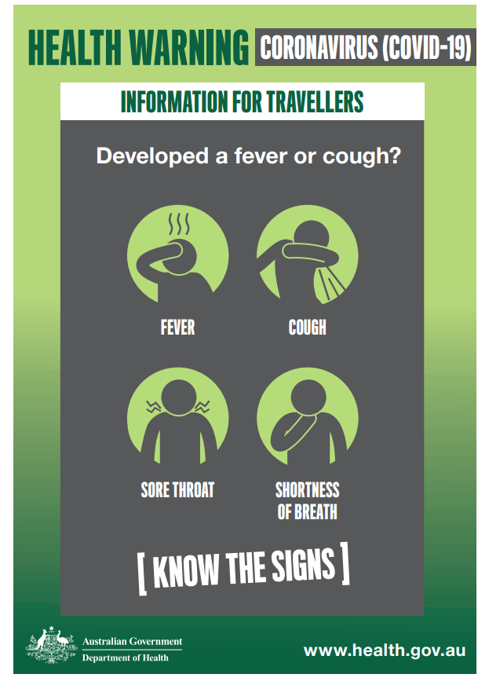
    - Poster – Stop the spread
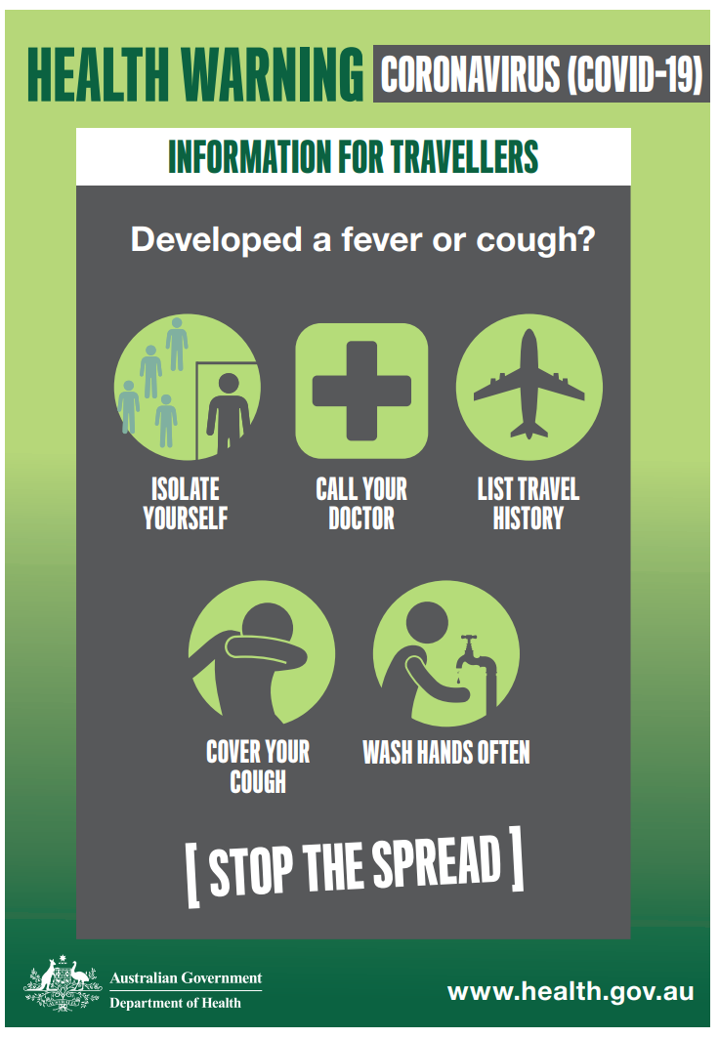

Pre-work COVID-19 Questionnaire (Client)
Date: |  | Type of Work: | ☐ Indoor  ☐ Outdoor
Client Name and Address
Description of work: |  | Work to be Conducted by:
Have you (or anyone at the address or living with you) been overseas and returned to Australia OR travelled interstate within the last 14 days? |  | ☐ YES  ☐ NO
Have you (or anyone at the address or living with you) been instructed to Self-Isolate? |  | ☐ YES  ☐ NO
Have you (or anyone at the address or living with you) had contact with a confirmed case of COVID-19 |  | ☐ YES  ☐ NO
Do you or have you have any of the following symptoms in the last 14 days? |  | ☐ FEVER  ☐ COUGH  ☐ FATIGUE  ☐ SORE THROAT  ☐ HEADACHES  ☐ ACHES AND PAINS  ☐SHORTNESS OF BREATH
It is a requirement that you always remain at least 2m from our employee whilst they are on site.  Please confirm your understanding and agreement to this requirement. |  | ☐ YES – I understand and agree to comply.
DECLARATION

I acknowledge that I understand the questions and have answered them honestly. If I develop any of the symptoms listed above, I will immediately contact Company Name and advise.
Signature of Client (or name of client if completed via phone or email).
Signature of Company Name representative

Authorised to work? No authorisation if client answers YES to any question. Work is to be postponed for 14 days and medical clearance obtained. |  | ☐ YES ☐ NO

Pre-work COVID-19 Questionnaire (Subcontractor/ Supplier)
Date: |  | Type of Work: | ☐ Indoor  ☐ Outdoor
Supplier/Subcontractor Name
Site Address
Description of work: |  | Work to be Conducted by:
Have you (or anyone at the address or living with you) been overseas and returned to Australia OR travelled interstate within the last 14 days? |  | ☐ YES  ☐ NO
Have you (or anyone at the address or living with you) been instructed to Self-Isolate. |  | ☐ YES  ☐ NO
Have you (or anyone at the address or living with you) had contact with a confirmed case of COVID-19 |  | ☐ YES  ☐ NO
Do you have any of the following symptoms? |  | ☐ FEVER  ☐ COUGH  ☐ FATIGUE  ☐ SORE THROAT  ☐ HEADACHES  ☐ ACHES AND PAINS  ☐SHORTNESS OF BREATH
It is a requirement that you always remain at least 2m from our employee whilst they are on site.  Please confirm your understanding and agreement to this requirement. |  | ☐ YES – I understand and agree to comply.
DECLARATION

I acknowledge that I understand the questions and have answered them honestly. If I develop any of the symptoms listed above, I will immediately leave the site and contact Company Name.
Signature of Subcontractor or Supplier
Signature of Company Name representative

Authorised to work? No authorisation if any question is answered YES – subcontractor/supplier is not permitted on site for 14 days and medical clearance must be obtained before returning to site. |  | ☐ YES ☐ NO

    - Risk Assessment for COVID-19
Description
Prepared by (print) |  | Prepared by (sign) |  | Position |  | Date
Authorised by (print) |  | Authorised by (sign) |  | Position |  | Date

Hazard | Risk | Current Control Measures | Evaluate Current Controls – Do we need to implement additional controls? |  |  | Enter  New control measures recommended | By Who | By When
 |  |  | Yes | No | N/A
Someone entering the workplace with COVID-19 | A visitor or client enters the workplace with COVID-19 and passes the virus on to employees. | - An information document/poster highlighting the symptoms of COVID-19 is placed on the entry/sign in point of the workplace, and other designated locations (i.e.: notice boards and bathrooms). The poster will state that symptomatic individuals will not be allowed entry.  - Formal communication (i.e.: an email) is sent to regular visitors and contractors which highlights the risks of COVID-19 and states that symptomatic individuals will not be allowed entry or will be requested to leave.  - A COVID-19 specific workplace induction to be developed identifying (but not limited to) workplace expectations and proper personal hygiene requirements (i.e.: handwashing.), social distancing and symptoms of COVID-19  - This information has been passed onto employees.
Someone becomes ill within the workplace | Employees, visitors  Contracted COVID-19 by any means. | - Identified person/s will be removed to a designated area, which is at least 2 metres away from other people, and are isolated behind a closed door.  - The individual will be sent home and advised to follow Health Department guidance online. If the person is a visitor, their organisation will also be contacted.  - The workplace will be decontaminated following Governmental guidance:  https://www.health.gov.au/sites/default/files/documents/2020/03/environmental-cleaning-and-disinfection-principles-for-covid-19.pdf  - This information has been passed onto employees.
Contaminated workplace | Employees, visitors  A person catches COVID-19 due to contaminated surfaces. | - An increased formal cleaning regime is underway. Employees are cleaning equipment more often (i.e.: keyboards, work surfaces, door handles etc.).  - Hand sanitisers have been placed in the workplace.  - Extra hygiene requirements (i.e.: handwashing) are enforced.  - Multi-use handtowels are not used to dry hands.  - The workplace will be decontaminated following Governmental guidance:  https://www.health.gov.au/sites/default/files/documents/2020/03/environmental-cleaning-and-disinfection-principles-for-covid-19.pdf  - This information has been passed onto employees.
Proximity, workplace gatherings | Employees  A person catches COVID-19 due to working closely with an infected person. | - A Social Distancing policy has been implemented.  https://www.health.gov.au/resources/publications/coronavirus-covid-19-information-on-social-distancing  - All work areas and activities have been evaluated against the possibility to implement social distancing (no handshaking, deferring large meetings etc.)  - This information has been passed onto employees
Proximity, Sharing Vehicles | Employees  A person catches COVID-19 due to working closely with an infected person. | - Employees are to take separate vehicles to work sites where possible.  - If it is not possible to take separate vehicles due to company operational needs, employees not having a vehicle or licence, the following controls will be implemented:  - The vehicle is to be cleaned with all items sanitised and cleaned daily.  - Employees to follow Hand Hygiene before and after travel.
Picking up materials from supplier premises | Employees, retail employees, general public.  A person catches COVID-19 due to contaminated surfaces or contact with any unknown infected persons. | - Employees must comply with social distancing guidelines while at retail premises.  https://www.health.gov.au/news/health-alerts/novel-coronavirus-2019-ncov-health-alert/how-to-protect-yourself-and-others-from-coronavirus-covid-19/social-distancing-for-coronavirus-covid-19  - Paper towel or disinfectant wipes are to be used when handling materials or touching surfaces within retail premises.  - Employees must avoid unnecessarily touching materials and surfaces in retail premises.  - Employees must wash their hands or hand sanitise immediately after leaving the premises.  - Employees must avoid touching their face and hair until they have washed their hands or used hand sanitiser.  - https://www.health.gov.au/resources/publications/coronavirus-covid-19-print-ads-good-hygiene-is-in-your-hands
General | Employees (including those considered at increased risk)  Employees are not aware of the risks from COVID-19 and become infected due to lack of awareness of control measures | - The Health Department provides advice on what COVID-19 is, what the risks are, the symptoms, how COVID-19 is spread, and how to avoid catching or spreading germs (simple Do’s and Don’ts):  https://www.health.gov.au/news/health-alerts/novel-coronavirus-2019-ncov-health-alert  - The WHO (World Health Organisation) provides information and a free 5-minute video on which has been provided to our employees COVID-19:  https://openwho.org/courses/introduction-to-ncov  - Government guidance on hand washing is provided in line with the 20 second rule:  - https://www.health.gov.au/resources/publications/coronavirus-covid-19-print-ads-good-hygiene-is-in-your-hands  - Additional consideration will be given to those employees who may be deemed to be at increased risk.  - Advice on risks, symptoms and control measures has been passed onto employees. A training program has been implemented.  - Infection Control Training Online - https://www.health.gov.au/resources/apps-and-tools/covid-19-infection-control-training
Self-isolation | Employees  Employees are not aware of the need to self-isolate or how to self-isolate. | - Australian Health Department provides advice on when to self-isolate:  https://www.health.gov.au/resources/publications/coronavirus-covid-19-isolation-guidance  - Advice on how to self-isolate has been passed onto employees.
Travel  (Travelling abroad and interstate) | Employees  Travelling abroad for work to an area with a higher risk of COVID-19. | - International Travel is no longer permitted.  - Interstate travel is restricted - comply with government restrictions.
Travel  (Returning from travelling abroad or interstate) | Employees  Returning to the Australia or your own state after travelling abroad or interstate. | - Employees are required to Isolate for 14 days and will be stood down from work.  - Where possible, a working from home arrangement may be entered dependant on operational and equipment requirements.
Symptomatic or exposed Employee(s)  Presenteeism | Employees, general public, family members  Employee(s) is/are symptomatic of COVID-19 or has been in close contact with someone with COVID-19.  A person catches COVID-19 due to another employee continuing to work despite being unwell. | - Employee(s) is/are advised to follow Health Department Guidance:  https://www.health.gov.au/news/health-alerts/novel-coronavirus-2019-ncov-health-alert?utm_source=health.gov.au&utm_medium=redirect&utm_campaign=digital_transformation&utm_content=health-topics/novel-coronavirus-2019-ncov  - If it is determined the employee is symptomatic and they are unfit for work, they will be treated as off sick as per normal policy.  - Symptomatic employees will be sent home.  - Colleagues who have had contact with a symptomatic employee will be made aware of the symptoms and advised to contact the Coronavirus Hotline for guidance.  - Working from home will be considered.  - A specific home working risk assessment will be conducted.  - As a last resort, if we decide to suspend an employee as a precaution this will be done in line with FairWork Guidelines.  - This advice or how to access it is passed onto employees
Employee(s) who have contracted CV19 | Employees, general public, family members  Contracted COVID-19 by any means. | - If an employee has contracted COVID-19 they will be treated as off sick as per normal policy.  - Colleagues who have had contact with a symptomatic employee will be made aware of the symptoms and advised to follow Health Department guidance.  - The workplace will be decontaminated following Governmental guidance:  https://www.health.gov.au/sites/default/files/documents/2020/03/environmental-cleaning-and-disinfection-principles-for-covid-19.pdf  - Personal Protective Equipment has been provided relative to activities.  - This information has been passed onto employees.
Lack of accurate information / a failure to disseminate information | Employees (including those considered at increased risk)  Employees are not aware of the risks from COVID-19 and become infected due to lack of awareness of control measures. | - Monitoring. We have designated a COVID-19 Appointed Person. Responsibilities include:  - Checking the Online Health Alert: https://www.health.gov.au/news/health-alerts/novel-coronavirus-2019-ncov-health-alert  b) Monitoring other relevant Websites and News outlets.  - Reporting. The designated person is to report to management all updates for consultation with staff.
Attendance to client homes to undertake work. | Exposure to COVID-19 at client home. | - Company Name will request any clients to maintain a minimum distance of 2m whilst working in their home.  - Hand Hygiene to be performed with Soap and Water prior to entering client home and again upon leaving – Employee may use an outside tap for this, followed by a hand sanitiser.  - All clients are screened prior to attending their premises for works to ensure they have not been exposed to COVID-19 (using Pre-Work COVID-19 Questionnaire).  - Cash payments are no longer accepted.  - Where possible, employee is not to enter client home (unless work area is within the home).  - Shoes are to be removed.  - If work is required for any client who has travelled overseas, is in isolation or has been in contact with a known case, the following additional precautions undertaken:  - Work not to be undertaken unless an emergency.  - For EMERGENCY Work Additional Guidance can be sought from the Coronavirus Hotline; however, as a minimum:  - Disposable Gloves to be worn whilst in the client home at all times.  - Hand Hygiene prior to and after client visit.  - Mask may be worn by employee or client may be requested to wear a mask (guidance recommends masks are more efficient on the sick person).  - Do not touch any surface unnecessarily.  - Clean down any surface before touching with approved cleaner (e.g. bathroom taps, fixtures etc).  - Consideration of additional PPE to be worn (depending on work being undertaken):  - Approved P2 or N95 respirator/face maskpproved  - Protective coverall  - Nitrile Gloves  - Foot Booties
Plumbers undertaking sewerage works | Exposure to COVID-19 in Sewer Pipe | - Hand Washing with soap and water as per procedure below, both before and after undertaking work.  - No food is to be eaten near the work area, with appropriate hand hygiene before and after.  - Correct handwashing procedure:  - Wet hands with running water  - Place soap on palms  - Rub hands together to make a lather  - Scrub hands vigorously for 20 seconds  - Dry hands with a disposable towel  - Turn off tap using the disposable towel  - Correct use of hand rubs:  - Place alcohol-based hand rub on palms  - Apply to all surfaces of hands  - Rub hands together until dry  - Infection Control Training to be undertaken  - Employees to be trained in risks of COVID-19  - Appropriate PPE to be worn to protect from potential infection including:  - Approved P2 or N95 respirator/face mask  - Protective coverallsProtective coverall  - Nitrile Gloves  - Foot Booties
Employees returning to work or their homes after being at client premises or working with a client. | Risk of infection to other Employees.  Risk of infection to household members | - Employees are not to return to a centralised location – where possible. Employees should go straight home from their normal work.  - Where a vehicle needs to be returned to the company depot, or there is another operational reason to return to the depot, the Employee must perform hand hygiene after arriving. They must clean inside vehicle in accordance with the guideline issued by the health department : https://www.health.gov.au/sites/default/files/documents/2020/03/environmental-cleaning-and-disinfection-principles-for-covid-19.pdf  - When returning home, the following are to be implemented:  - Do not touch anything inside the home  - Remove shoes  - Leave bag, wallet and keys near the entrance to the home Remove clothes and place in a bag for washing  - Have a shower – if this is not possible, wash all exposed areas.  - Wash Mobile Phone and Glasses with hot soapy water or alcohol (disinfectant).  - Clean with bleach all the surfaces of whatever has been brought in from outside before storing it.

Health & safety risk assessment - Briefing record
If the risk assessment is updated the briefing of the changes must be recorded.
By signing below, I acknowledge that I have received a health and safety briefing on the topic(s) covered by the above risk assessment
First name | Surname | Signature | Time | Date |  | First name | Surname | Signature | Time | Date

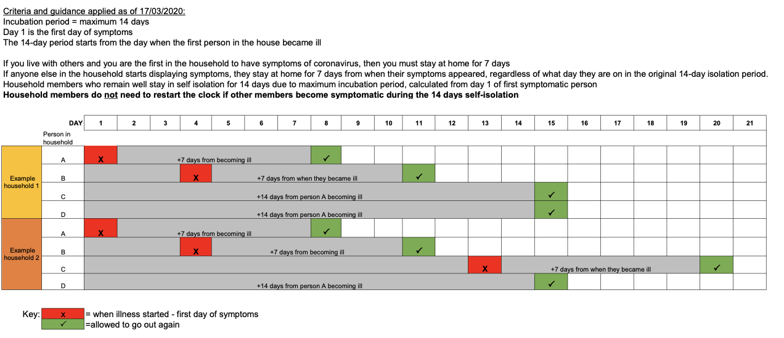
END OF DOCUMENT

